How to Test

Installation
Execute install.sh in package. Then choose the options to install the packages.

Apache
- Opening a browser and keyin the IP address of Moxa embedded computer as the URL, you should see a “Test Page” shown on browser.
- If there isn’t shown any page, you have some methods to check what happens.
    - Using command ‘ps ax | grep httpd’ to check if there are httpd processes running at background. If there are httpd processes running, but browser shown nothing, you might lose the index page, try to write one by yourself and put it in the directory ‘/usr/www/html/’.
    - If there isn’t any httpd process running, try to start the web server by ‘/etc/init.d/apache start’
    - If you still can’t make the web server work, try to upgrade firmware and reinstall again.
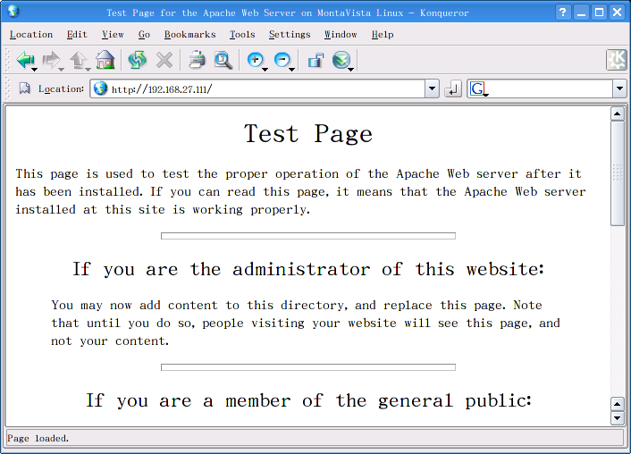

Apcahe + PHP
- After installing Apache + PHP, you also get a copy of phpinfo.php in the directory ‘/usr/www/html’. It will help you to check if PHP works or not, and it also show many PHP settings, these information is very important when you develop your web pages by PHP.
- Just opening http://EmbeddedComputer-IP/phpinfo.php, you will see the PHP information shown on the browser.
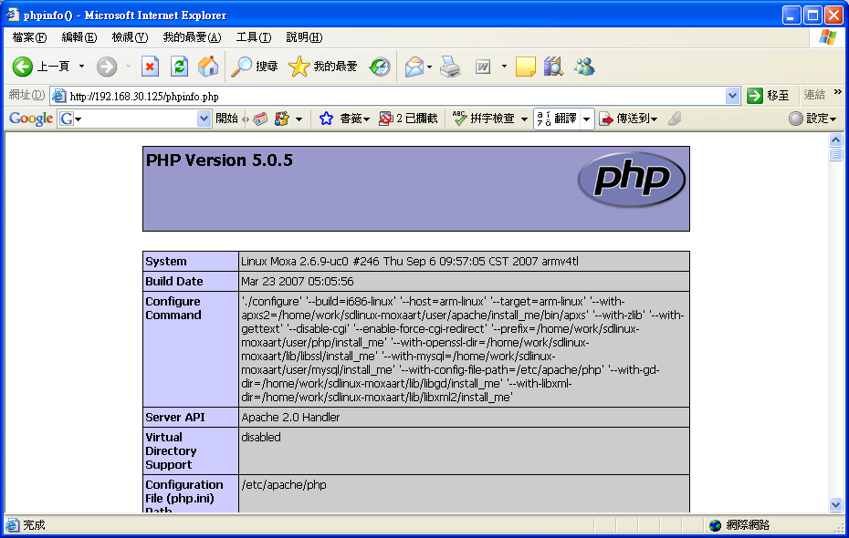

Reference
- Apache HTTP Server Official Website - http://httpd.apache.org/
- PHP Official Website - http://www.php.net/
- mod_ssl Official Website - http://www.modssl.org/
- MySQL Official Website - http://www.mysql.com/

